Implementing micro services on AWS

# for Post

{

"httpMethod": "$context.httpMethod",

"student": $input.json('$')

}

#for GET

{

"httpMethod": "$context.httpMethod",

"id": $input.params('id')

}

1. App.java

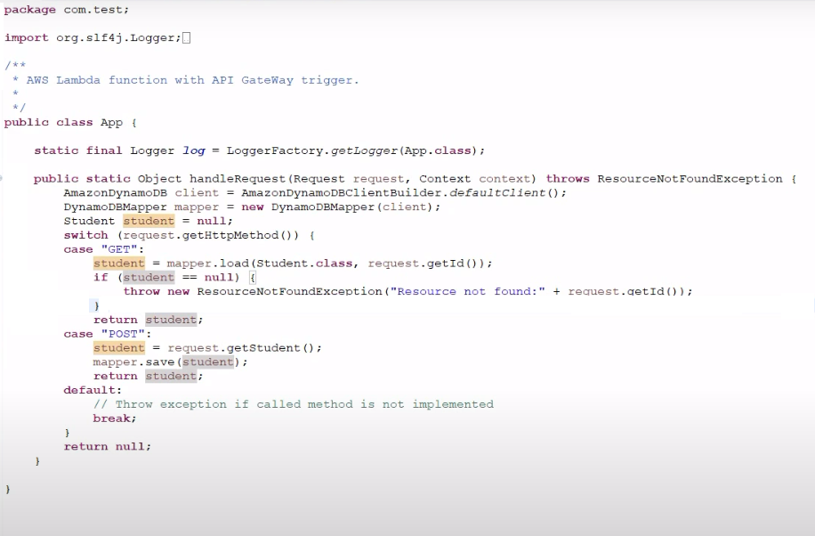

2. Student.java

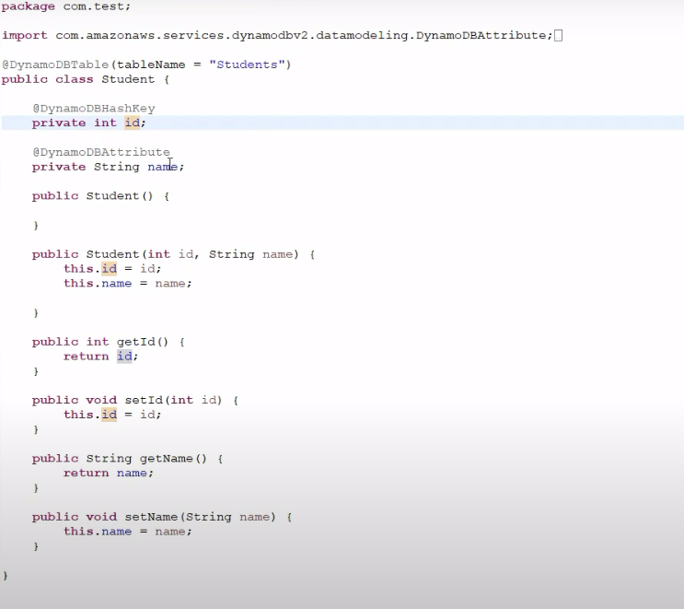

Request.java

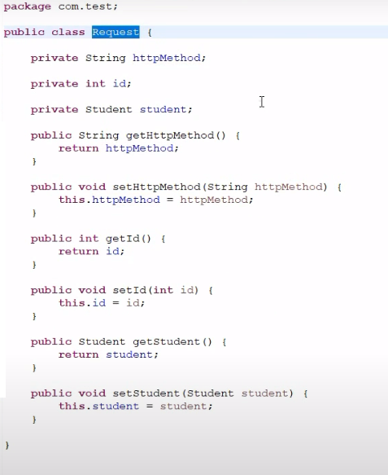

ResourceNotFoundException

